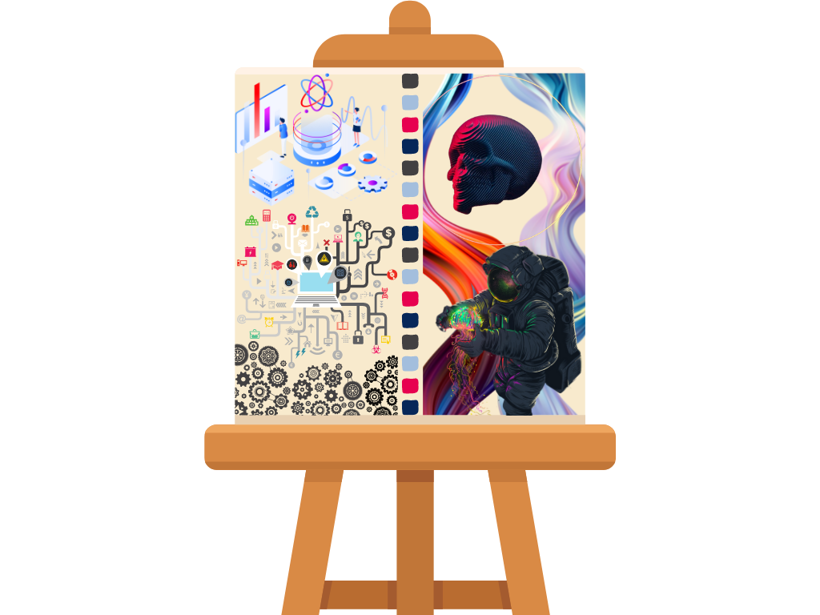

Explanation

Through my perspective, I see myself as a art canvas depicted above. But not just a plain, blank canvas – parts of me have already been painted, predefined notions of myself that I have come to gain over the course of my life. In a more scientific sense, I halved myself between my logical and theoretical side, which is on the left, and my artistic, creative side, which is on the right.

This depiction is fairly similar to the capabilities of the different halves of the human brain. In this similar fashion, the canvas shows the building blocks of what describes me. On the left, shown clearly is my love for technology and the vast ever-changing world of computers and my deep interest to the workings behind everything. Incidentally, my creative side is explicitly shown on the right half of the canvas. I am fairly committed to learning a lot about digital art and the aesthetics of it which is a combination of my love for traditional art and technology.

Despite having all of this describe me, there is still parts of the canvas, parts of me that are empty. This depicts that I still have room to grow and to improve and a lot to gain along my journey in life. I am not solely bound to the merits I’ve obtained up until now but I am a canvas ready to be painted once again.